//Programs on Garbage collection in java

public class GarbageCollectionDemo

{

public void finalize()

{

System.out.println ("Garbage Collection performed by JVM");

}

public static void main (String args[])

{

GarbageCollectionDemo s1 = new GarbageCollectionDemo ();

GarbageCollectionDemo s2 = new GarbageCollectionDemo ();

s1 = null;

s2 = null;

System.gc();

}

}

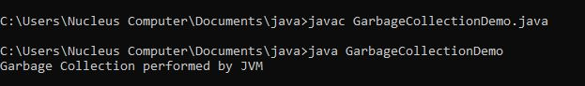

//programs on packages in java

//access Modifiers,